Eric Percival  AEA • SAG-AFTRA  917.566.3752  espercival@gmail.com  www.ericpercival.com | 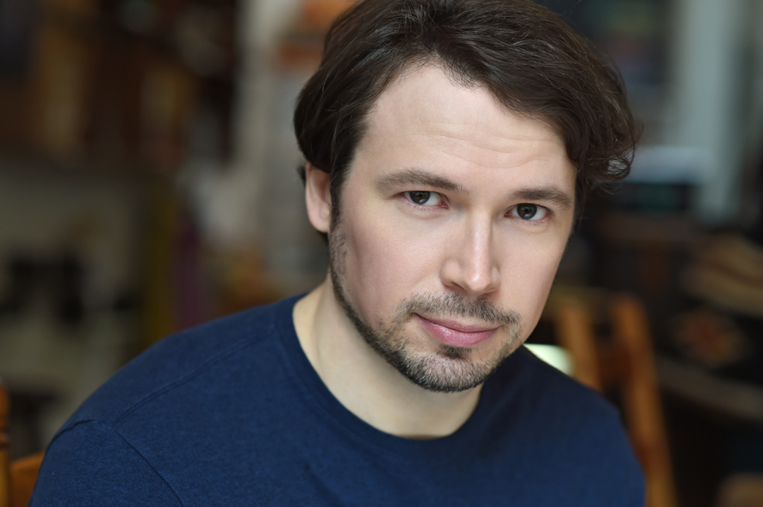
Height: 5’10” Weight: 175 lb Hair: Brown Eyes: Hazel Voice: Baritone
Film/TV
The Lepers  Carol’s Last Chance  Farm Story (series pilot)  Carter Reed  The Sonnet Project  Men of Manhattan | Vin (Lead)  Gus (Lead)  Kyle (Lead)  Carter (Lead)  Sonnet 20 (Lead)  Lead | Val Terranova Productions  Yellow Bear Productions  Going to Tahiti Productions  Cool Hand Productions  NY Shakespeare Exchange  School of Visual Arts
Theatre
My Purple Wig  Mr. Bengt’s Wife  A Snowfall in Berlin  100 Saints You Should Know  The Gruesomely Merry  Adventures of Nell Dash  The Picture of Dorian Gray  Island; Or To Be or Not To Be  Hamlet Bound and Unbound  Another Horatio Alger Story  Ros. and Guil. are Dead  Twelfth Night  Cat on a Hot Tin Roof  Romeo and Juliet  The Story of Anne Frank | Tom  Mr. Bengt  Coates  Father Matthew  Edward Ferrars/  Sweeney Todd  Basil Hallward  King John  Robert (Hamlet)  Horatio Alger  Rosencrantz  Sir Toby Belch  Brick  Benvolio/Paris  Henk Geis | Theatre Row Lion Andrea Andresakis  August Strindberg Rep Craig Baldwin  Nylon Fusion Shaun Peknic  Urban Stages Joan Kane  NY Theatre Festival Dennis Corsi  MT Works Glory Kadigan  NY Shakespeare Exch. Ross Williams  Midtown Int’l Thtr Fest Joan Kane  Metropolitan Playhouse Jim Gaylord  T. Schreiber Studio Cat Parker  Natural Perspectives, London  LAMDA  LAMDA Tour England/Holland/Germany  National Theatre of the Perf. Arts
Training

- London Academy of Music and Dramatic Art (LAMDA): 2-Year Post-Grad Acting Program
Rodney Cottier, Colin Cook, Helena Kaut-Hewson, more
- T. Schreiber Studio: Scene Study Terry Schreiber, Page Clements
- Connecticut College: BA, Theater/Philosophy - David Jaffe, Linda Herr, more
- National Theater Institute: Intensive Semester Course - Richard Digby Day, more

Special Skills/Awards

- Accents: British RP (highly fluent), Irish, Cockney, Southern American, excellent ear for accents.
- Midtown Int’l Theater Fest: Outstanding Lead Actor, “Jonny” in Bubby’s Shadow
- Planet Connections Fest: Best Supporting Actor, “Basil Hallward” in The Picture of Dorian Gray

